Web Application Security Assessment Report
1. Cover Page
Project Title:
Web Application Vulnerability Assessment Using DVWA
Prepared By:
Sufiyan Pathan
Role:
Cybersecurity Intern
Organization:
Future Interns
Date:
11/12/2025
2. Introduction
This security assessment was conducted as part of a cybersecurity internship project to identify common web application vulnerabilities using ethical hacking techniques. The assessment focused on a deliberately vulnerable web application to understand how attackers exploit weaknesses and how such issues can be mitigated.
The goal of this project was to:
Identify security flaws using manual testing
Map vulnerabilities to OWASP Top 10 categories
Document findings with evidence
Provide remediation recommendations
3. Scope of Assessment
✅ In-Scope Application
Application Name: Damn Vulnerable Web Application (DVWA)
Deployment: Docker (Localhost)
URL: http://127.0.0.1:8080
Security Level: Low (for learning & testing)
❌ Out-of-Scope
External websites
Production systems
Any application not owned by the tester
4. Tools & Environment Used
Kali Linux – Security Testing OS
Docker – Application deployment
DVWA – Vulnerable test web app
Firefox – Manual Testing
Manual Payloads – Exploitation
Screenshots – Evidence Collection
5. Methodology
The assessment followed a structured approach:
1)Application setup and verification
2)Identification of input fields and attack surfaces
3)Manual testing of vulnerabilities
4)Exploitation using safe payloads
5)Evidence collection (screenshots)
6)Risk evaluation
7)OWASP Top 10 mapping
8)Remediation recommendations
6. Identified Vulnerabilities (Summary)
NO.  1.  2.  3. | Vulnerability  SQL Injection  Reflected XSS  CSRF | Severity  High  Medium  High | OWASP ID  A03-Injection  A03-Injection  A01-Broken Access control

7. Detailed Vulnerability Findings
🔴 7.1 SQL Injection
Affected Page:
DVWA → SQL Injection
URL:
http://127.0.0.1:8080/vulnerabilities/sqli/
Payload Used:
' OR '1'='1
Description:
The application directly includes user input in SQL queries without validation, allowing attackers to manipulate the database query structure.
Result:
All user records were displayed, bypassing intended access control.
Impact:
Unauthorized access to sensitive data
Potential data modification or deletion
Severity: High
OWASP Mapping:
✅ A03 – Injection
Evidence:
Screenshots showing payload entry and multiple user data output.
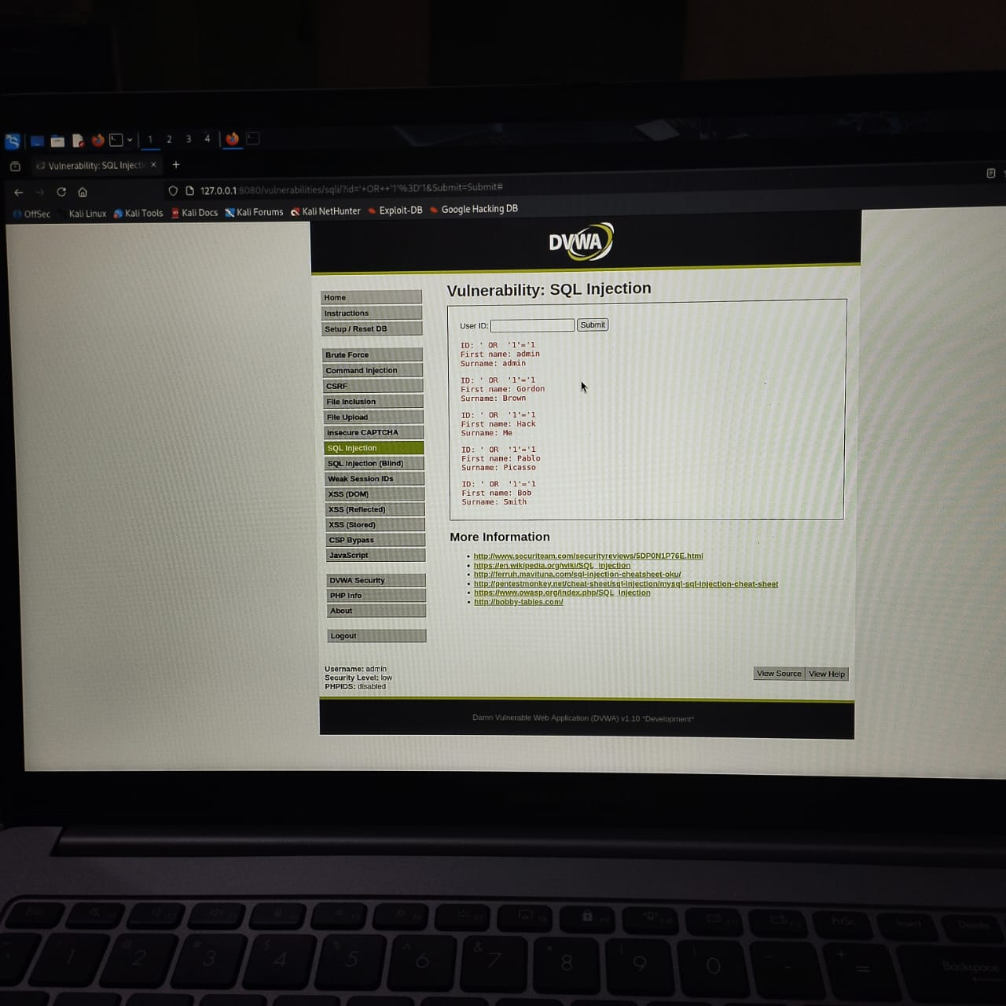
🔴 7.2 Reflected Cross-Site Scripting (XSS)
Affected Page:
DVWA → XSS (Reflected)
URL:
http://127.0.0.1:8080/vulnerabilities/xss_r/
Payload Used:
<script>alert(1)</script>
Description:
User input is reflected in the response without sanitization, allowing execution of malicious JavaScript code.
Result:
A JavaScript alert executed successfully in the browser.
Impact:
Session hijacking
Credential theft
Phishing attacks
Severity:
Medium
OWASP Mapping:
✅ A03 – Injection
Evidence:
Screenshot showing alert popup execution.
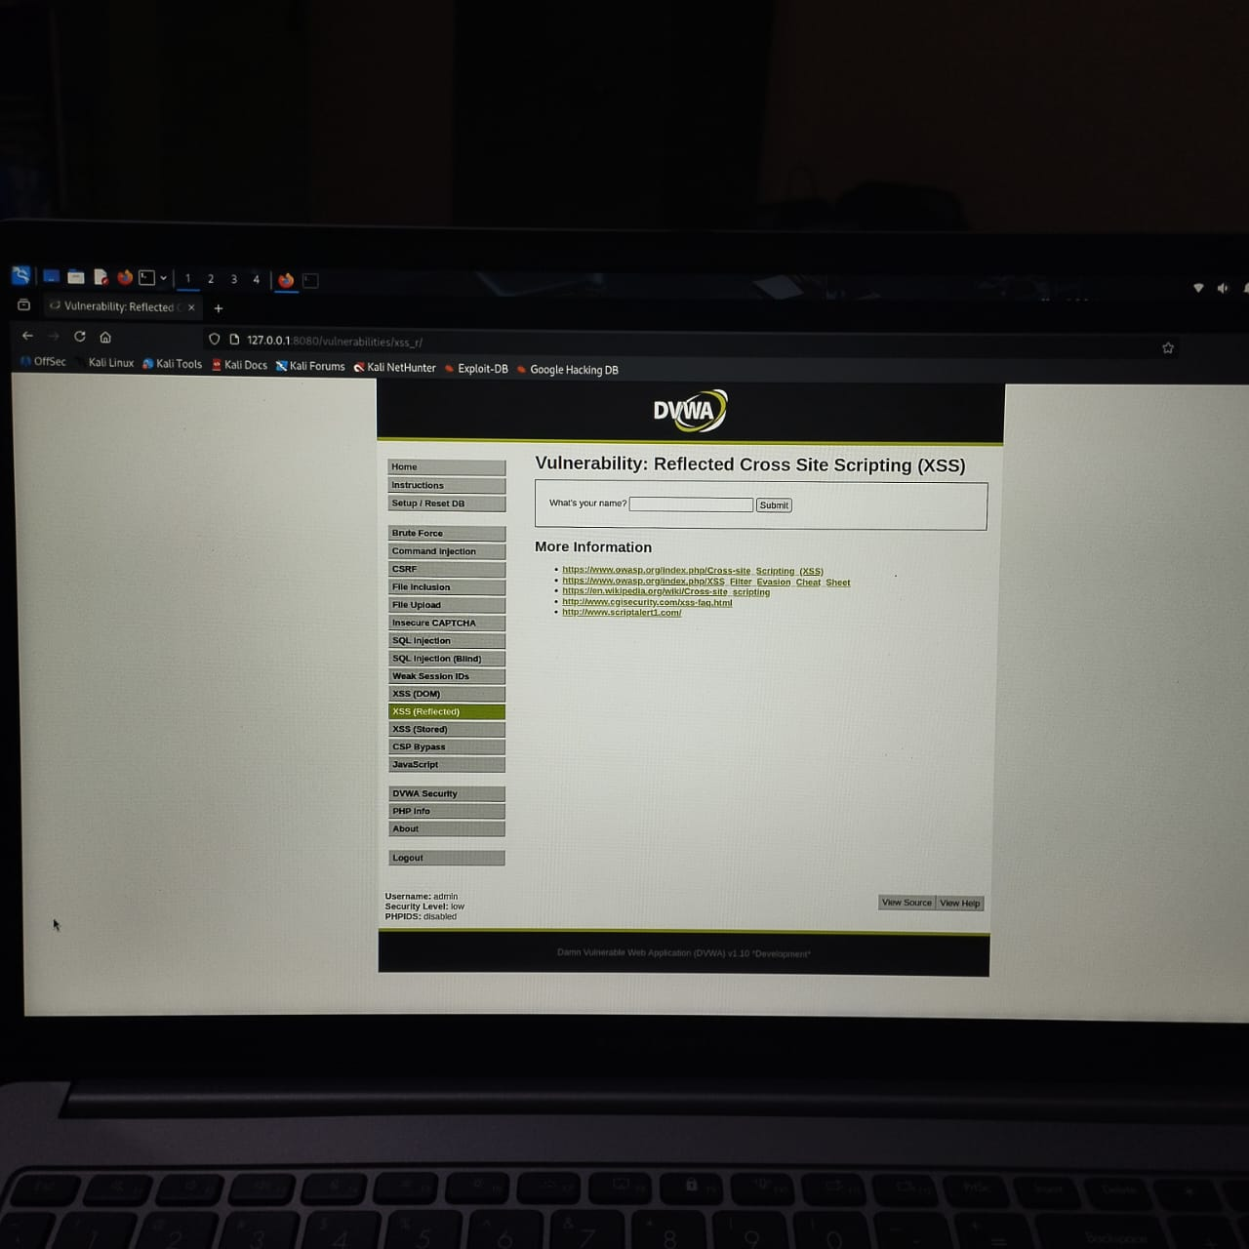

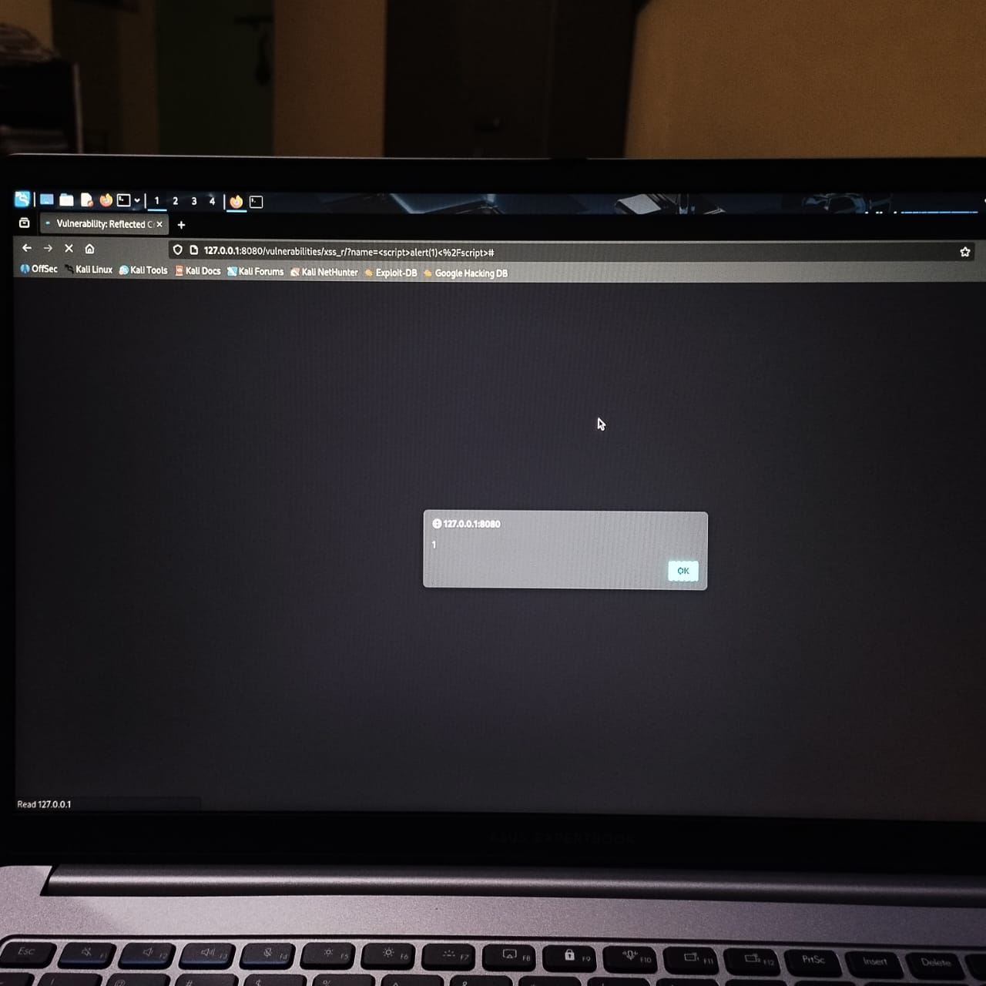
🔴 7.3 Cross-Site Request Forgery (CSRF)
Affected Page:
DVWA → CSRF
Attack URL:
http://127.0.0.1:8080/vulnerabilities/csrf/?password_new=hacked123&password_conf=hacked123&Change=Change
Description:
The application allows sensitive actions (password change) without verifying request origin or intent.
Result:
Password was changed successfully without using the form.
Impact:
Unauthorized password modification
Account compromise
Severity: High
OWASP Mapping:
✅ A01 – Broken Access Control
Evidence:
Screenshots of password change confirmation and successful login using the new password.
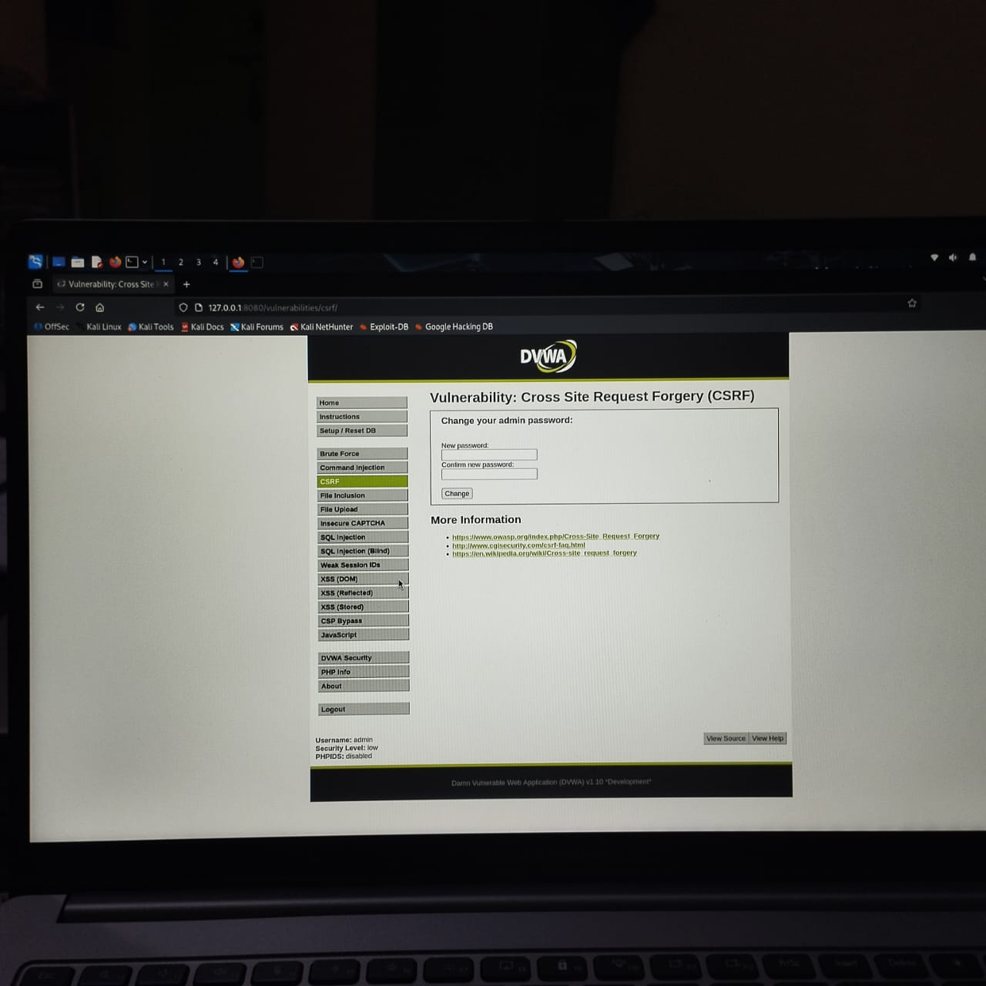

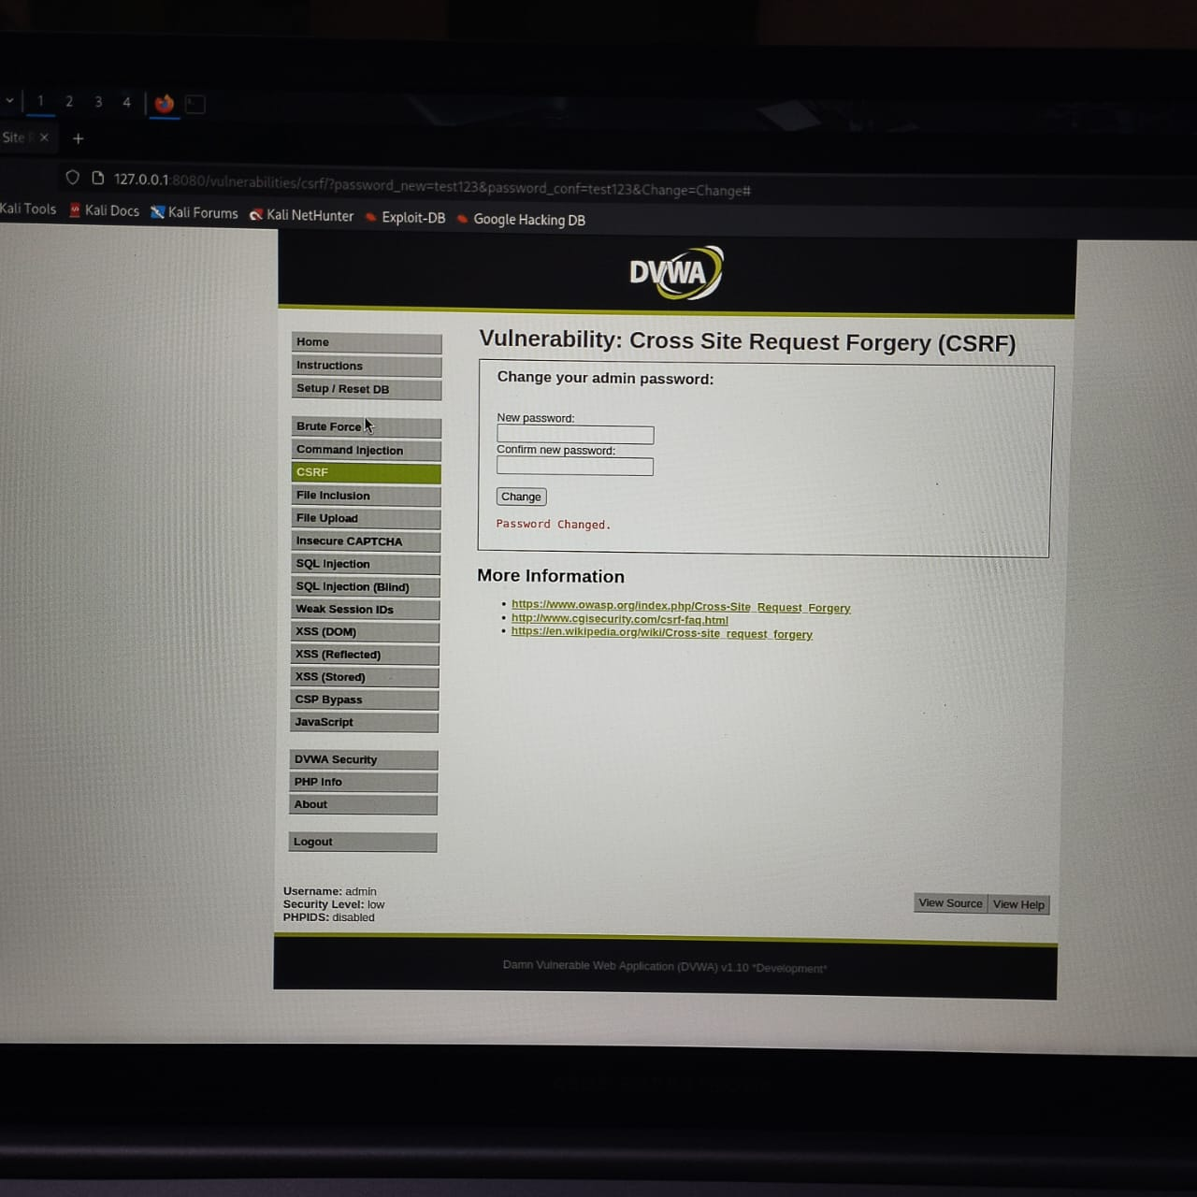
8. OWASP Top 10 Mapping
Vulnerability  - SQL Injection  - Reflected XSS  - CSRF | OWASP Category  Injection  Injection  Broken Access Control | OWASP ID  A03  A03  A01

9. Remediation Recommendations
✅ SQL Injection
Use parameterized queries
Validate and sanitize all inputs
Apply least-privilege DB access
✅ Cross-Site Scripting (XSS)
Encode output before rendering
Implement Content Security Policy (CSP)
Sanitize user input
✅ CSRF
Implement anti-CSRF tokens
Enforce POST for sensitive actions
Validate Origin and Referer headers
10. General Security Recommendations --
Keep components updated
Disable verbose error messages
Use secure HTTP headers
Perform regular security audits
Follow OWASP Secure Coding Practices
11. Conclusion --
This assessment successfully identified multiple critical web application vulnerabilities mapped to the OWASP Top 10 framework. Exploitation of these vulnerabilities demonstrated how attackers could compromise data integrity, user accounts, and application security.
By implementing the recommended remediation measures, the overall security posture of the application can be significantly improved.

